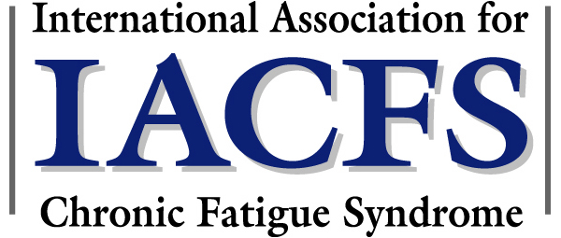

Dedicated to the Promotion of Scientific Research and Improved Patient Care

BOARD OF DIRECTORS

We are inviting researchers and clinicians who have authored peer review articles in the area of chronic fatigue syndrome (as you have) to join the International Association for Chronic Fatigue Syndrome (IACFS; Formerly the American Association for Chronic Fatigue Syndrome). The mission of the IACFS is to promote scientific research and improved patient care in this underserved population.
We recognize that important scientific and clinical research in CFS/ME is being done internationally. Our membership as well as our Board of Directors reflect this worldwide participation in the study of CFS/ME. We value our international members and we ask that you join us.
What do we offer? The IACFS provides exciting opportunities to network with fellow researchers and clinicians at our professional conferences and to receive our publications –a peer review journal and a quarterly newsletter. Our biennial meeting offers a unique experience for interested scientists from around the world: (1) to get the latest updates on cutting edge research, (2) to present papers and participate in interactive seminars, and (3) to network with others in this growing field. Our next meeting will be in January, 2007 in sunny Ft. Lauderdale, Florida.
IACFS is a non-profit organization which depends solely on members and donors to support its research, service to patients, and educational mission. We are asking you to join our organization to support our vital mission.
Over the past decade, a groundswell of research has begun to explore the complex immune, neuroendocrine, cardiovascular, metabolic, and CNS/ANS underpinnings of this serious illness. It has never been more important to give the IACFS a stronger voice -- to advance innovative research and to promote the worldwide recognition of CFS/ME. The IACFS supports this critical work by sponsoring CFS/ME-related conferences, by educating our peers, and by disseminating knowledge about CFS/ME.
You can help the IACFS to have a strong international voice just by joining the organization.
Membership benefits include:
- IACFS quarterly newsletter subscription.
- Complimentary copies of the 2005 issues of the Journal of CFS.
- Website and printed listing in the Directory of Members.
- Reduced conference registration
Please show your support by completing and returning the attached Membership / Donor Application or online at www.AACFS.org.

We hope to hear from you!

Nancy Klimas, MD

Nancy Klimas, M.D.

President, IACFS

PRESIDENT
Nancy G. Klimas, MD
Dept. of Medicine
Univ. of Miami School of Medicine
Miami, FL

VICE PRESIDENT
Leonard A. Jason, PhD
Center for Community Research
DePaul University
Chicago, IL

SECRETARY
Lucinda Bateman, MD
Fatigue Consultation Clinic
Salt Lake City, UT

TREASURER & PAST PRESIDENT
Dharam V. Ablashi, DVM, MS,
Dip. Bact.
National Cancer Institute
NIH, Retired

David S. Bell, MD
Lyndonville, NY

Kenny De Meirleir, MD, PhD
Vrije Universiteit Brussel
Brussel, Belgium

Birgitta Evengard, MD, PhD
Karolinska Institutet
Stockholm, Sweden

Patricia A. Fennell, MSW, CSW-R
Albany Health Management, Inc.
Latham, NY

Hirohiko Kuratsune, MD, D.Med.Sci.
Dept. of Molecular Medicine,
Hematology, and Oncology
Osaka University Graduate School
of Medicine
Osaka, Japan

Charles W. Lapp, MD
Email: Admin@aacfs.org | 27 N. Wacker Dr., #416 | Voice: 847-258-7248
Web: www.aacfs.org | Chicago, IL 60606 | Fax: 847-748-8288

Hunter Hopkins Center
Charlotte, NC

Lyle D. Lieberman, Esq, J.D.
Lieberman, Gutierrez
& Merlino, P.A.
Miami, FL

Lee B. Meisel, MD, JD
Boca Raton, FL

Stanley N. Schwartz, MD
Inter ID, Inc.
Tulsa, OK

